Basic Input and Output Statements

Program:

Output:

Data Types

Program:

Output:

Data Operations

Program:

Output:

Control Statements

Program:

Output:

Access Modifiers

Program:

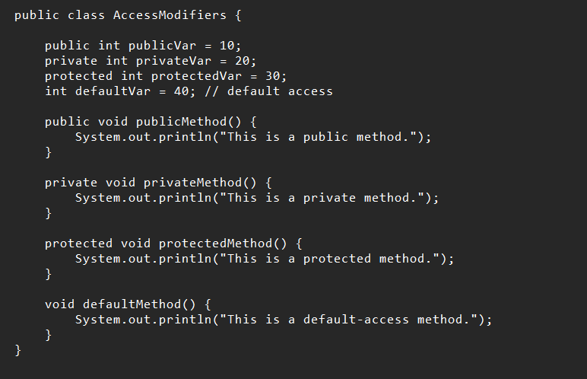

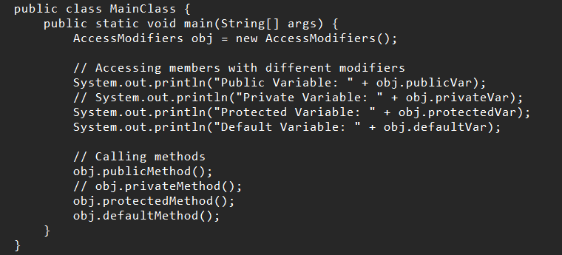

Output:

